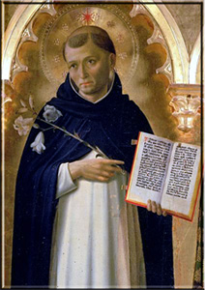
Novena Prayer to St. Dominic
(to be said for nine consecutive days)
O glorious Saint Dominic, thou who wast a model of mortification and purity, by punishing thy innocent body with scourges, with fastings and with watchings, and by keeping inviolate the lily of thy virginity, obtain for us the grace to practice penance with a generous heart and to keep unspotted the purity of our bodies and our hearts.
Our Father, Hail Mary, Glory be.
O great Saint, who, inflamed with divine love, didst find thy delight in prayer and intimate union with God; obtain for us to be faithful in our daily prayers, to love our Lord ardently, and to observe His commandments with ever increasing fidelity.
Our Father, Hail Mary, Glory be.
O glorious Saint Dominic, who, being filled with zeal for the salvation of souls, didst preach the Gospel in season and out of season and didst establish the Order of Friars Preachers to labor for the conversion of heretics and poor sinners, pray thou to God for us, that He may grant us to love all our brethren sincerely and to cooperate always, by our prayers and good works, in their sanctification and eternal salvation.
Our Father, Hail Mary, Glory be.
V. Pray for us, Saint Dominic,
R. That we may be made worthy of the promises of Christ.
Let us pray:
Grant, we beseech Thee, Almighty God, that we who are weighed down by the burden of our sins may be raised up by the patronage of blessed Dominic Thy Confessor. Through Christ our Lord. Amen
(Indulgence of 300 days once a day)

